Campaign Progress Report
Period: 22July–10 August
Organization: KOH E ZAN Educational Reforms

1. Grounding in Vision

1.1 Campaign Vision
Our campaign vision is to build a culture of accountability in the education system and society. We believe that accountability is the foundation of quality education: teachers must be present and prepared, schools must be responsive, and communities must actively participate.
Long-Term Change We Want to Build
Our vision connects to our long-term change — a society where education is a shared responsibility, where all this factors are present:
- Accountable Schools
Principals leading with responsibility to ensure discipline, regular classes, and teacher performance.
Regular monitoring by DDO, Education Department, and SMCs to keep schools transparent and effective.
- Motivated Teachers & Active Learning
Teachers supported with training, recognition, and guidance.
Activity-based and creative teaching methods to make learning enjoyable and effective.
- Empowered Parents & Strong SMCs
Parents actively engaged through PTMs and decision-making.
Restructured, functional SMCs leading community accountability and school improvement.
- Interested & Confident Students
Students developing a genuine love for studies through interactive and engaging classes.
Equal encouragement for boys and girls to participate, ask questions, and excel.
- Equal Access for Girls
Girls supported and encouraged to continue education at every level.
Community and religious leaders actively advocating for girls’ education.
What are this month specific goals and outcomes

This Month’s Goals were:
- Meetings with teachers, principals, SMC, and DDO.
- Organize PTM with SMC restructuring.
- Meeting with DDE Education to:
  - Share campaign awareness.
  - Request training for SMCs.
  - Highlight science teacher shortage.
  - Ask about Education Department rules and content for SMC training & SDP.

Outcomes Achieved:
- Meetings with DDO & principals led to commitments for monitoring & centralized exams.
- PTM held, inactive SMC members replaced, and new members added.
- Science teacher shortage raised collectively by SMC, parents, and teachers → Committee formed & proposal submitted to Finance Minister during his Saltoro visit.
- On 10th August, delegation met DDE Ghanche, who:
  - Appreciated the campaign and assured SMC training support.
  - Confirmed that Education Department rules & content for SMC training will be shared.
  - Promised that campaign team will be invited to upcoming SMC & SDP trainings.
  - Assured follow-up visit and solution for science teacher shortage.

How do activities in this reporting period connects back to our vision and goals
- Accountability: Meetings with DDO, principals, teachers, and SMCs improved monitoring, discipline, and leadership.
- Community Involvement: PTM and SMC restructuring made parents active in decision-making and strengthened accountability.
- Quality Teaching: All Saltoro DDO-level meeting encouraged activity-based methods to boost student interest in studies.
- Institutional Linkages: Meeting with DDE connected our campaign to the Education Department for SMC training, resolving teacher shortages, and future planning.
- Snowflake Growth: One-on-one and circle discussions with parents, mothers, girls, and leaders expanded our network and campaign reach.
Together, all these activities are moving us toward accountable schools, motivated teachers, active parents, and students who enjoy learning with equal opportunities for girls.

1.2 Purpose Check: Why the Saheli Circle?
Why are you running a Saheli circle as part of your campaign?
We are running a Saheli Circle as part of our campaign because almost all students in Saltoro do not ask questions in class, show little interest in their studies, and often lack confidence. The Saheli Circle provides a safe and supportive space where students can share their thoughts, learn to ask questions, build self-confidence, and develop essential life skills, which are the right of every student. In addition, they will learn leadership, decision-making, communication, and negotiation skills, enabling them to actively participate in school and community life. By encouraging open discussion and peer support, the Saheli Circle helps students become active learners, take greater interest in education, and prepare for life beyond school.
What role is it playing in your campaign strategy -Awareness , base building, narrative shift , organizing?
The Saheli Circle is playing a key role in awareness, base building, and organizing in our campaign strategy. By bringing together all girls students in Saltoro, it helps raise awareness about their rights, the importance of education, and the campaign itself. The girls also share this awareness with their parents, creating a stronger community understanding. Its main purpose is to build their interest in studies and prepare them to actively question and hold teachers accountable. Through peer support and skill-building activities, the Circle organizes girls around shared issues like education participation, leadership, and life skills, strengthening their collective voice and fostering active participation in school and community decisions.

How are you using the circle to move others to act not just attend?

The Saheli Circle ensures that girls do not just attend sessions but actively participate in the campaign. Through discussions, skill-building activities, and peer support, they develop confidence, leadership, communication, and decision-making skills. Equipped with these skills, girls encourage their peers to engage in school activities, ask questions, and hold teachers accountable. They also share their learning with parents, raising awareness and motivating action across the community. In this way, the Circle transforms passive attendance into active participation, expanding the campaign’s impact beyond the Circle itself.
2.Campaign Momentum: Visibility, energy and public action
- What actions or event did we do in this period?
During this period, we conducted multiple activities to strengthen school accountability, improve student interest, and expand our campaign network:

Meetings with High school Authorities: We met with DDO, principals, and teachers, with special support from Sir Shujaat, who highlighted the benefits of the campaign and provided motivational support. These meetings focused on improving teacher performance, student interest in learning, overall school monitoring, and importance of an active school management committee.

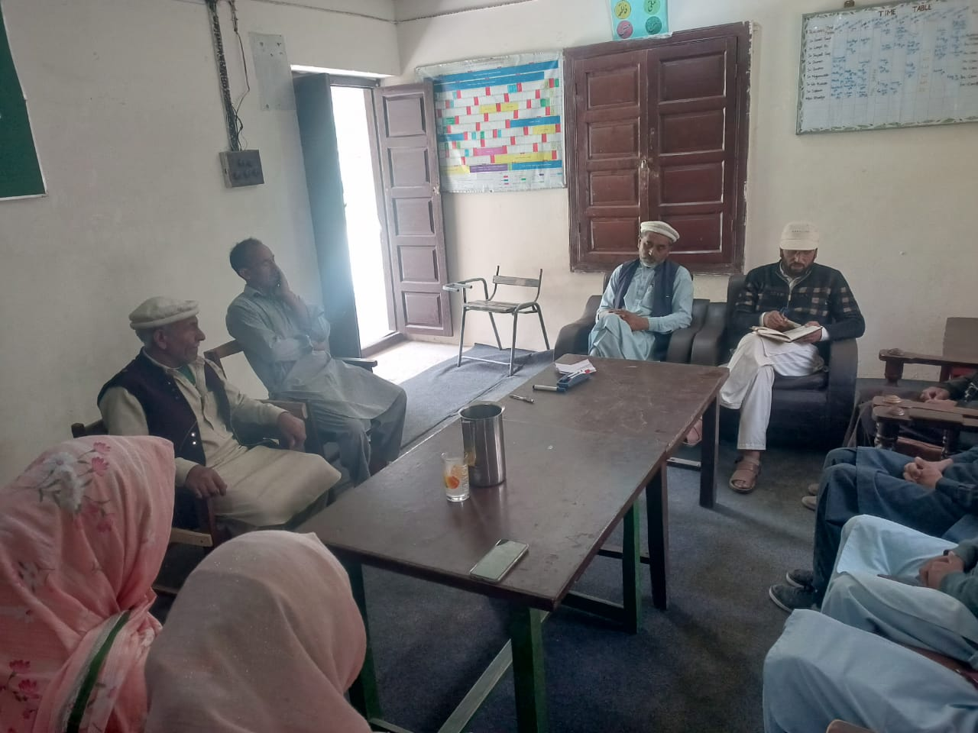

Meeting with DDE Ghanche: A delegation including LT member SMC members, community elder youth volunteers , (Ramzan Ali, Zahid Ali) met the DDE to raise campaign awareness, request SMC training, and highlight school issues, especially the shortage of science teachers. The DDE appreciated the campaign, assured SMC training support, promised to invite the team to upcoming training sessions, and confirmed a school visit.
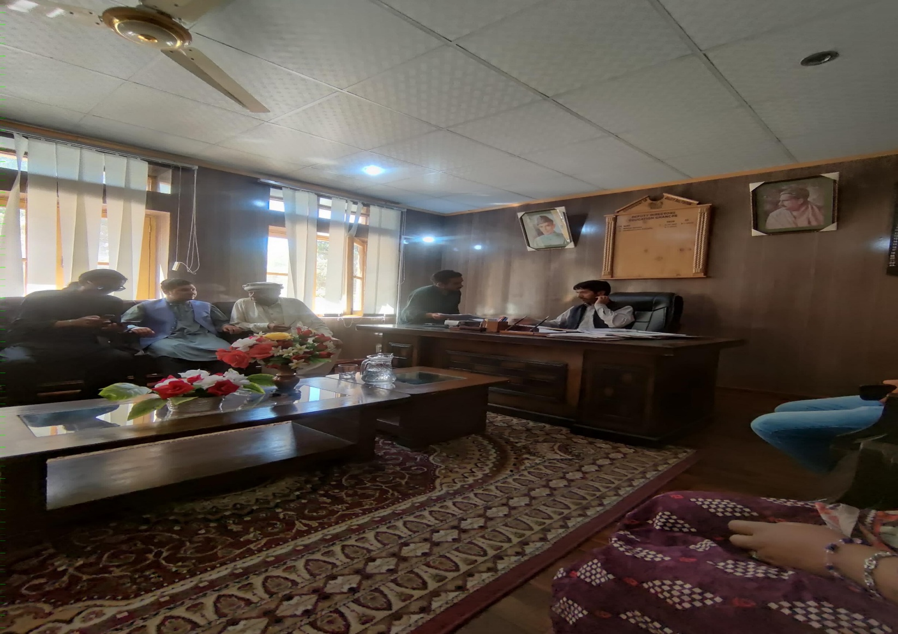

All Saltoro DDO-Level Meeting: We shared campaign goals with all teachers and school heads in Saltoro, promoting activity-based teaching to improve student interest. Teachers discussed classroom challenges and provided feedback for support strategies, responding positively to the campaign.
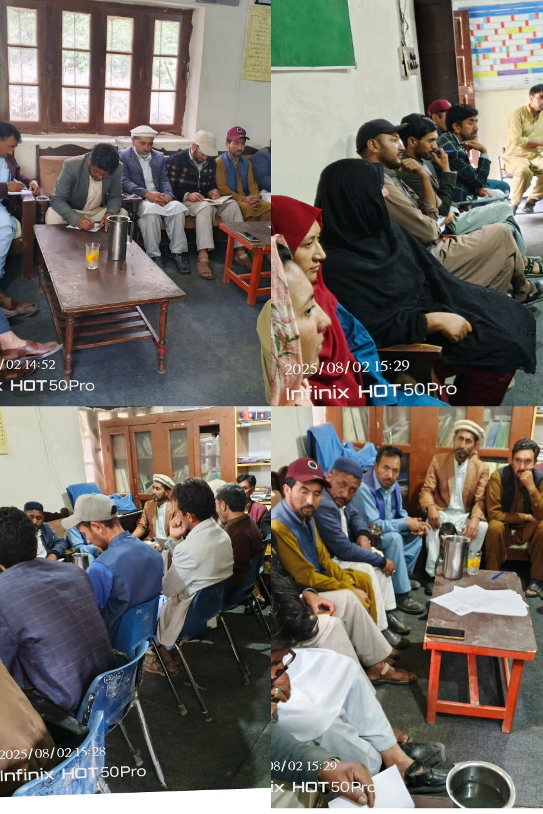

Parent-Teacher Meeting (PTM) & SMC Restructuring: Conducted a PTM involving parents, SMC members, and school heads. Inactive SMC members were replaced and motivated parents added. A committee was formed to address the science teacher shortage.

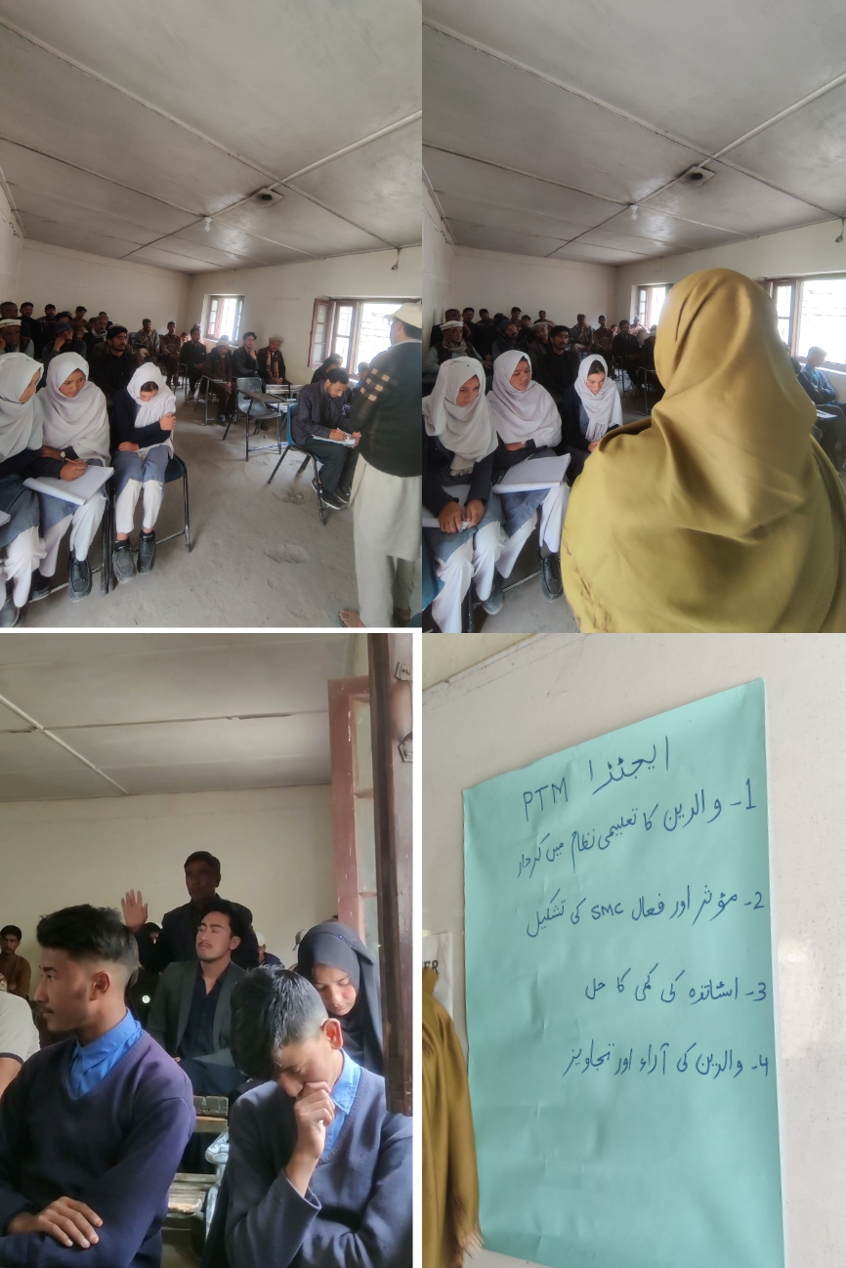

Committee Formation & Advocacy: The committee drafted a proposal on science teacher shortage, submitted it to the Finance Minister of GB during his Saltoro visit, and followed up with the DDE on 10th August, receiving assurances for resolution and support for SMC training.

Saheli Circles & One-on-One Engagement: LT members conducted circles in villages for girls and mothers, held one-on-one sessions with parents, teachers, and youth, expanding the snowflake network to 100+ members, including teachers, parents, students, youth volunteers, and religious leaders.
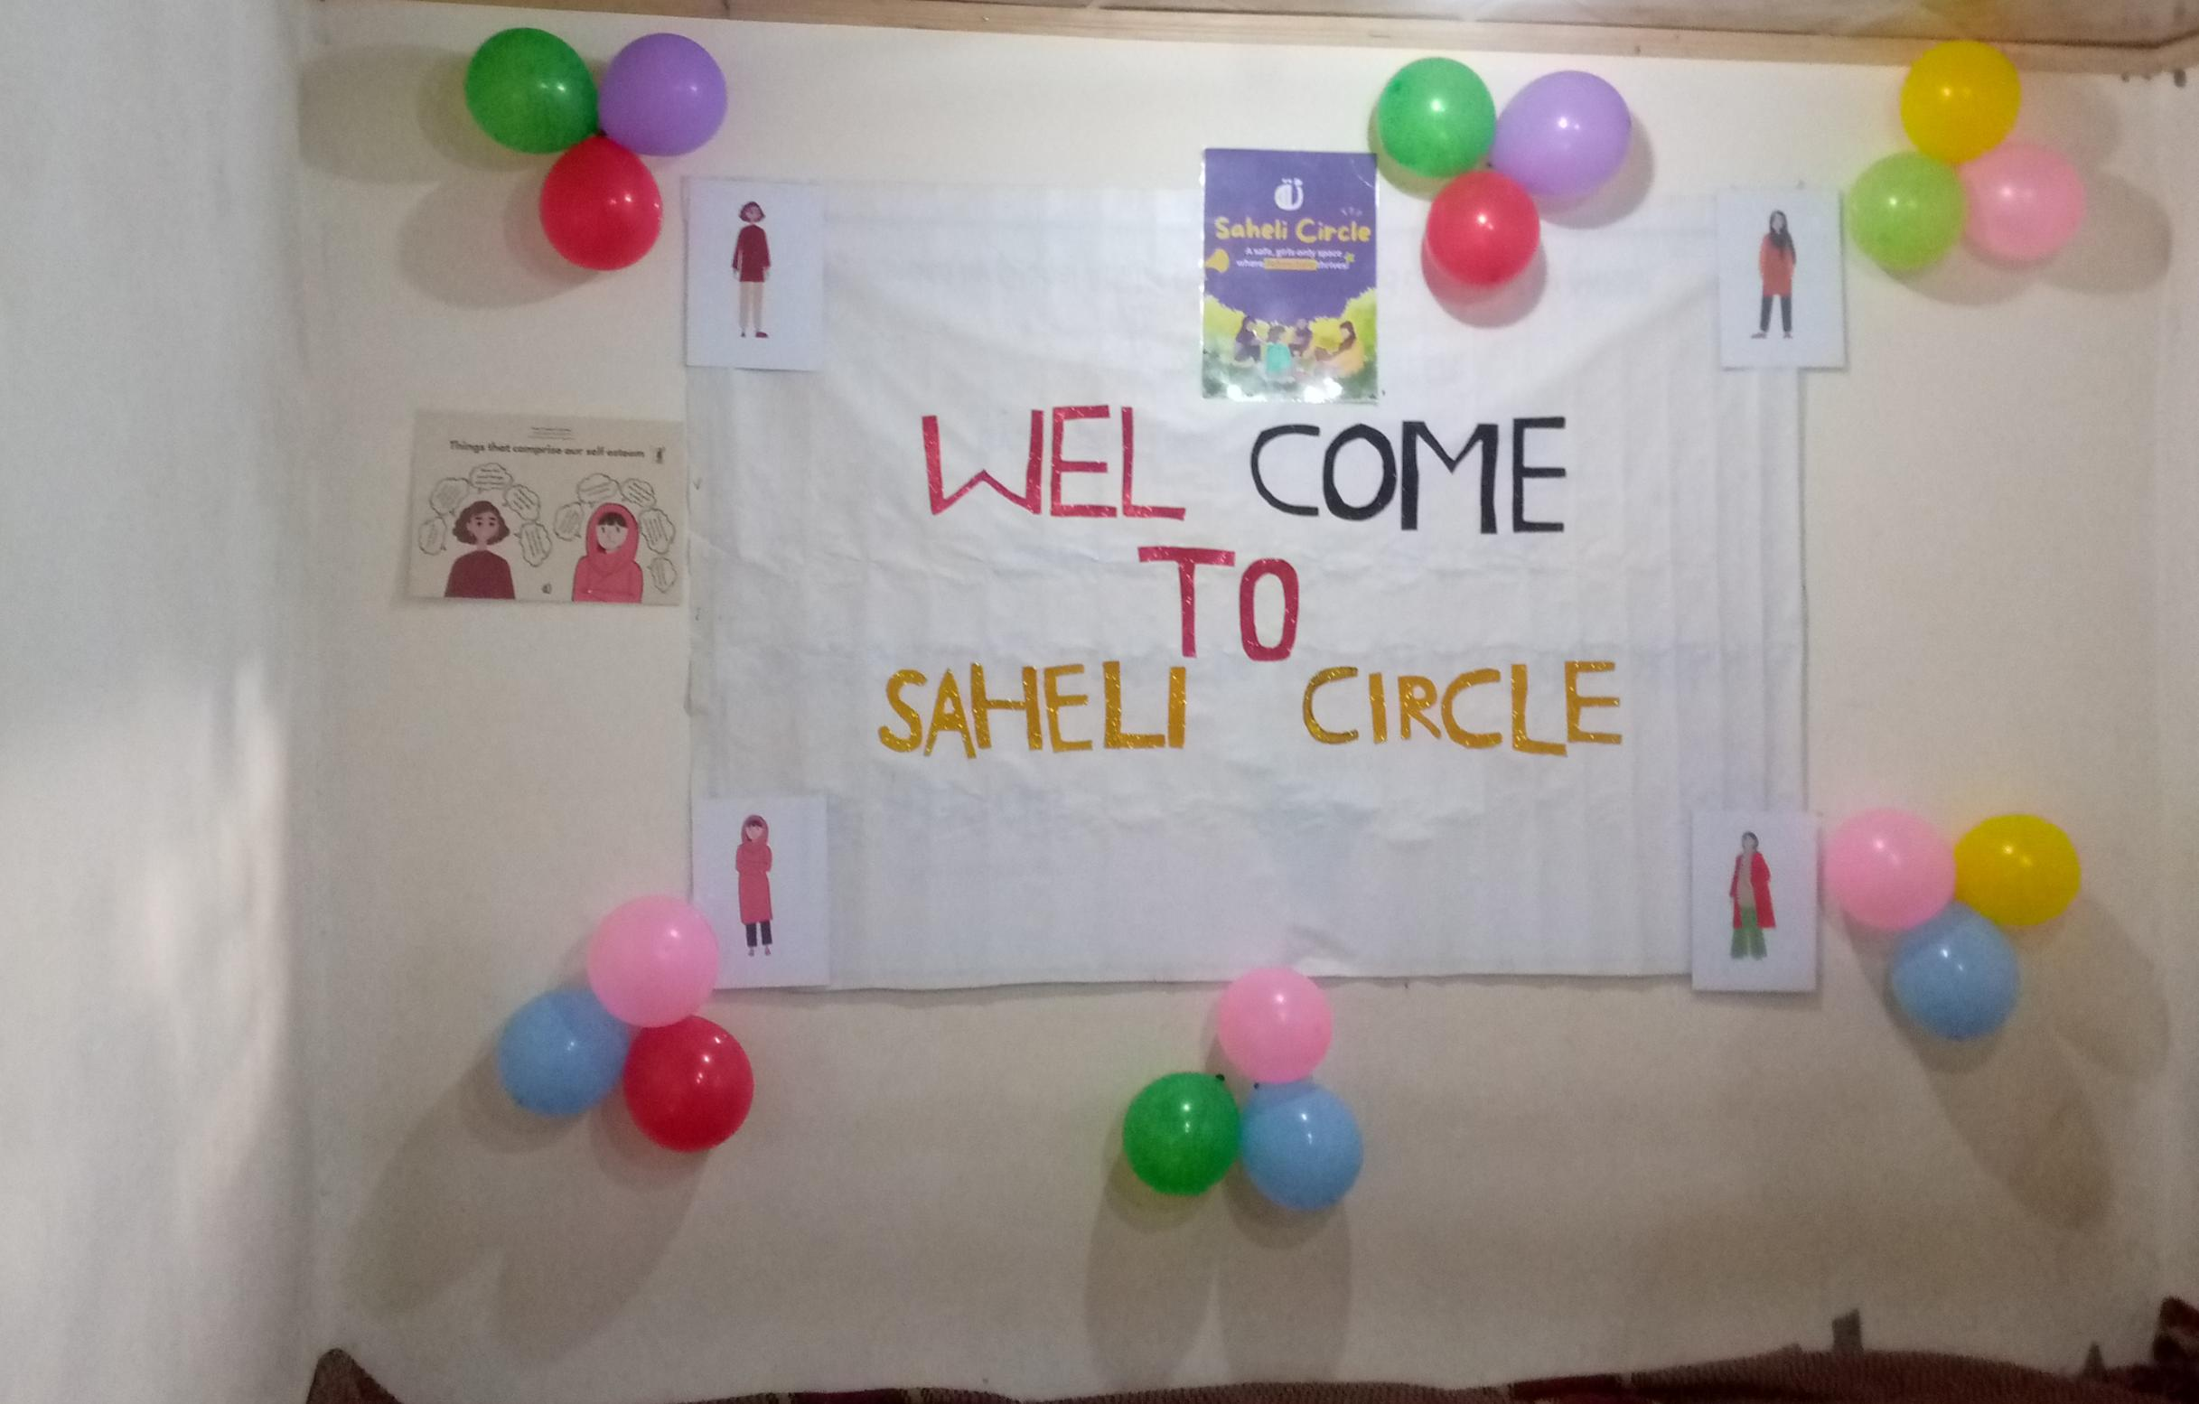

Engagement with Religious Leaders & Community Supporters: Engaged Sir Abdul Karim and Darvaish Ali to advocate for education in sermons. Parents like Noor Muhammad, father of 8 daughters, pledged full support and encouraged other parents to participate.

Meeting with LT member Rashida and Sakina at saith school where Rashida teachs as community teacher

Leadership Development & Empowerment: LT members Rashida and Sakina independently led Saheli Circles for the first time. Other LT members (Sara, Suriya, Tahira) formed mini-teams, mentoring new members and volunteers. Youth volunteers continued to support activities, including library-based Saheli Circle sessions.
- What visible wins did we have in this period?

Visible Wins in This period
Launching of Second Saheli circle:
Launched our second Saheli circle in Saltoro saith in collaboration with youth in their Library
PTM :
PTM was Conducted at high school where New SMC forms and parents and teachers discussed about different issues .
SMC Restructuring Achieved: Inactive members were replaced with motivated parents, strengthening accountability and community participation.
Committee on Science Teacher Shortage: A committee was formed and officially submitted a proposal to the GB Finance Minister and DDE, gaining assurance of action.
Education Department Recognition: The DDE acknowledged the campaign, assured SMC training support, and committed to inviting our team in future trainings and SDP planning.
Principal & Administrative Support:DDO, Principals, Teachers especially Sir Shujaat,Sir Najam , Sir Hassan and Miss Khadija supported the campaign, motivating others and validating its benefits in meetings.
Religious & Community Endorsement: Religious leaders joins our campaign and decide to advocate for education in sermons, while community members like Noor Muhammad, Mehdi, Zakir Ali, M.Abbas openly committed to supporting girls’ education.
Youth Volunteer Engagement: New volunteers (Ramzan Ali, Zahid, and others) joined and actively supported campaign activities, strengthening the snowflake.
Women’s Leadership Growth: LT members (Rashida, Sakina, Sara, Tahira, and Suriya) independently led circles and formed mini-teams, showing visible empowerment and confidence.
Did anything we do build visibility or create energy?

1.3 Goals for this Period
- Strengthen SMCs (School Management Committees).
- Build informal power with mothers, fathers, teachers, and religious leaders.
- Form Saheli Circles in every village.
- Raise voice about teacher shortages (especially in science subjects).
- Expand our snowflake structure to 100+ active members.

1.4 Activities Done This Period
- Restructured PTMs and included active SMC members.
- Organized Saltoro Teachers Conference to discuss teaching challenges.
- Raised issue of science teacher shortage with DDE and formed a follow-up committee.
- LT members conducted circle discussions with mothers and girls in different villages.
- One-on-ones with parents, teachers, principals, and imams.
- Expanded Saheli Circles in multiple villages.
- Engaged religious leaders to speak about education in sermons and kutbas.

2. Strategy Check & Power Analysis

2.1 Strategy Check
- Issue Focus: we are focusing on multiple issues (Existing Teachers motivation, weak school leadership, shortage of science teacher, weak implementation on time table ,)
- Approach: we are using different approaches for each issues like for teachers shortage and class sufferings we Build collective community voice rather than depending only on formal authorities , LT mobile parents and they come to school , there we mobile students in secondary section (Shumaila ,Shagufta student of class 10th spoke in the PTM that there classes are suffering from a long time so they need a teacher who come daily and facilitate them ) This starts a conversation in parents that the issue is real .
For other issues like Weak implementation on Time tables we will Talk to DDO and HM that they implement the time table .
- Organizing Actions: For the Issue , shortage of science teacher and SMC restructuring we Organize people as follows:
- -For this time we called parents of 9th and 10th .
- -we took data and number of each parent from school FBISE focal person
- - our team member started talking to them in villages one by one
- - we gave call to each of them and tell them why we are inviting them
- We focused to call mother also but due to long distance they can’t reach only 2 sister of a student came other then them all were males
- At the end we do some on on one like with Himayat Ali a young graduate from Saltoro and Amanat .
- 2.2 Power Analysis Table
Stakeholder | Engaged (Y/N) | How We Engaged | Power They Hold in Campaign
Girls | Yes | Saheli Circles, discussions | Influence power, future leaders
Mothers | Yes | Circle meetings, PTMs | Influence at household/community
Fathers | Yes | 1:1s, meetings  PTM (e.g., Noor Muhammad) | Decision-makers at home , social authority
Teachers | Yes | Teachers Conference, one-on-ones | Classroom power, student learning
Principals | Yes | Meetings (e.g., Sir Abid, Sir Ismail Saudi and Sir Sakhawat) | Formal power  School-level authority
School Management | Yes | PTM restructuring, added new members | Bridge between school & community informal+influence
Education Dept. | Yes | Meetings with DDE, proposals sent | Formal decision-making power
Religious Leaders | Yes | Engaged Abdul Karim & Darvaish Ali | Moral/spiritual influence, informal power
Youth leaders yes Engaged Ramzan ,Ali. High influence power
Gohar Ali, M.latif

3. Snowflake Structure: Who’s In, Who’s Leading, What’s Getting Done

3.1 Core Leaders (LT Members)
- Active LT Leaders (10): Rashida, Tahira Bano, Fiza Bano, Perveen, Sakina Anum, Sara Fida, Suriya Abbas, Syeda, Aqeela Bano Khadija and Shujaat Ali .
- Each one is leading circles and mobilizing in their own villages Khadija and Shujaat are newly joined they are teacher and do full support and cooperation with campaign and working for grow of snowflake.

3.2 New Additions
- LT We had add Khadija and Sir Shujaat Ali in our main team.
- Parents: Noor Muhammad (father of 8 girls, strong supporter) , Gh. Abbas (Sarkardah Saith) Zakir Ali existing SMC also a devoted parent.
- SMC Members: 4 new active members added.
- Teachers: Sir Abid (Principal, Gabkhorr Middle School), miss Fatima a senior teacher from Saltoro (She not only encourage us but also support us and offer her old house for saheli circle)other teachers from Teachers Conference.
- Religious Leaders: Sir Abdul Karim (Islamiyat teacher), Darvaish Ali (Imam Juma, Heldi).
- Youth Volunteers: Kashif Zahid, Ali, Ramzan Ali , Latif , .
- Mothers & Girls: From village Saheli Circles.
- Snowflake size now: 100+ active members.

3.3 Who’s Leading What?
- Rashida & Sakina: Leading Saheli Circles, mentoring youth. Sakina also lead madrasa and she is doing her work great.
- Sara & Suriya: Formed their own mini-teams in their villages (surya team also include her sister Khurshida who first came with her in capacity Building and her neighbor girls as there village volunteers).
- Tahira: She is a motivated LT member she is working as a mind set shifter in her village as she also talkes about education, because she couldn’t complete her education because of her early marriage and pregnancy . She also Brought in her father (school principal).
- Saida , perveen and Aqeela are not working properly and they are some how inactive
- Fiza , she is active in mobilization like mouth to mouth in her area and people trust her .
- Shujaat Ali he is supporting us in High school, doing our printing work.
- Khadija she is also organizing people and conducting circles with girls

3.4 Are People Taking Action?
Yes — members are taking real actions:
- Running Saheli Circles.
- Restructuring SMCs.
- Writing proposals to the government.
- Engaging principals, teachers, and imams.
- Parents like Noor Muhammad speaking publicly in support of girls’ education.

3.5 Nodes and Support
- Active Nodes: Mini-teams in Ghagolo, Gabkhorr, Heldi, and other villages.
- Inactive Nodes: Lt members saeeda and Aqeela are some how inactive, but In the start they conduct discussion with mothers,Some SMC members were inactive, but replaced with motivated ones.
- Support Needed: Training in facilitation, public storytelling, and accountability mechanisms.

4. Leadership Development & Relationship Building

4.1 First-Time Leadership
- Rashida & Sakina led Saheli Circles independently for the first time during flood days.

4.2 Empowered New Leaders
- Sara and Suriya empowered to form village mini-teams.
- Tahira empowered to engage her father.
- Youth volunteers empowered to manage library and circle activities.

4.3 Relationships Strengthened
- Parents: Noor Muhammad pledged lifelong support, mobilizing other parents.
- Teachers: Shared challenges in teaching and student interest.
- Education Dept.: Raised science teacher shortage, got positive response.
- Religious Leaders: Abdul Karim and Darvaish Ali pledged to promote education.

4.4 Public Voices
- Noor Muhammad (SMC member, father of 8 daughters) shared powerful story.
- LT leaders spoke in circles.
- Teachers voiced challenges in the conference.
- Religious leaders gave their support.

5. What’s Next? Planning Ahead

5.1 Next Actions
- Follow up and reporting on saheli circles and a snow flake gathering.
- Follow up on teacher shortage issue.
- We are finding that in government sectors due to lack of monitering and accountability the teachers loss their motivation and come to the point (nothing will change ) for this we will conduct discussion circle with them to know what is the actual cause?
- Discussion circles with girls in school what issues they are facing?
- There is a huge problem in school leadership as they are not even train from any where ,they are given the charge on the base of scale and seniority so it is the best time for their leadership training.
- There is working sessions in Saltoro so SMC training will be delayed but they are supporting us and doing their level best in the current senerio.
- Build more youth engagement in circles.

5.2 Support & Training Needed
- Public storytelling training for volunteers.

- Support and training materials and couching in principal leadership training
- Support in assessment in the feedback of teachers after circle although we will collect some things in written.

- Support to document community stories.

5.3 Ownership
Main leadership team, snow flake members , supporters, SMC , Girls and the school authority owns it

5.4 Building on Previous Work
- Builds on PTMs, Teachers Conference, committee formation we closely observe teacher, head teacher and draw the conclusion, also for students interest there are no opportunity given to them in their early schooling so they now became fed off or don’t took interest in studies.
- Strengthens trust and expands snowflake.

5.5 Expanding Inclusion
- Every circle and PTM brings in new members.
- From just girls → to mothers, fathers, teachers, Smc , youth volunteer to imams.
- Snowflake is now broad-based, not just same few and every one know us as KOH E ZAN Educational Reforms team in Saltoro

Snapshot of Key Metrics (This Period)
- # of new people engaged: 50+ (total 100+ snowflake).
- # of people who took action: 12+.
- # of people who led something: 8 LT + 3 mini-team leaders.
- # of relational 1:1s held: 170+.
- # of public stories told:15+
- # of nodes (mini-teams) active: 6+.
- # of total members in snowflake: 100+.
Financial Expenses:
Sr.no | Tactics | Expense | Total Pkr
1- | Travel(7 days LT capacity Building training) | 1500*7 | 10500
2- | Travel (3 Days life skills workshop for volunteers) | 1500*3 | 4500
3- | Stationary (Note pad+ pen LT members) | 1700+300 | 2000
4- | Stationary For training+saheli circles | 3500 | 3500
5- | Basket (for saheli circles) | 83*6 | 500
6- | Stationary (File + color paper for saheli circles ) | 300+240 | 540
7- | Refreshments  (For LT and volunteer during trainings) | 770+1450 | 3830
8- | Fomic sheat plus + flag + balloons for 14 august | 550+400 | 950
9- | Sticky note | 150 | 150
10- | Travel (Car rent Khaplu to goma ) | 1000*2 | 2000
11- | Refreshments PTM | 2650 | 2650
12- | Travel (Goma to Saith and mandik) | 2000+3000=5000 | 5000
13 | Monthly call and internet et package | 999 | 999
 |  | Total | 37119
 |  | Remaining | -7119

Bills:

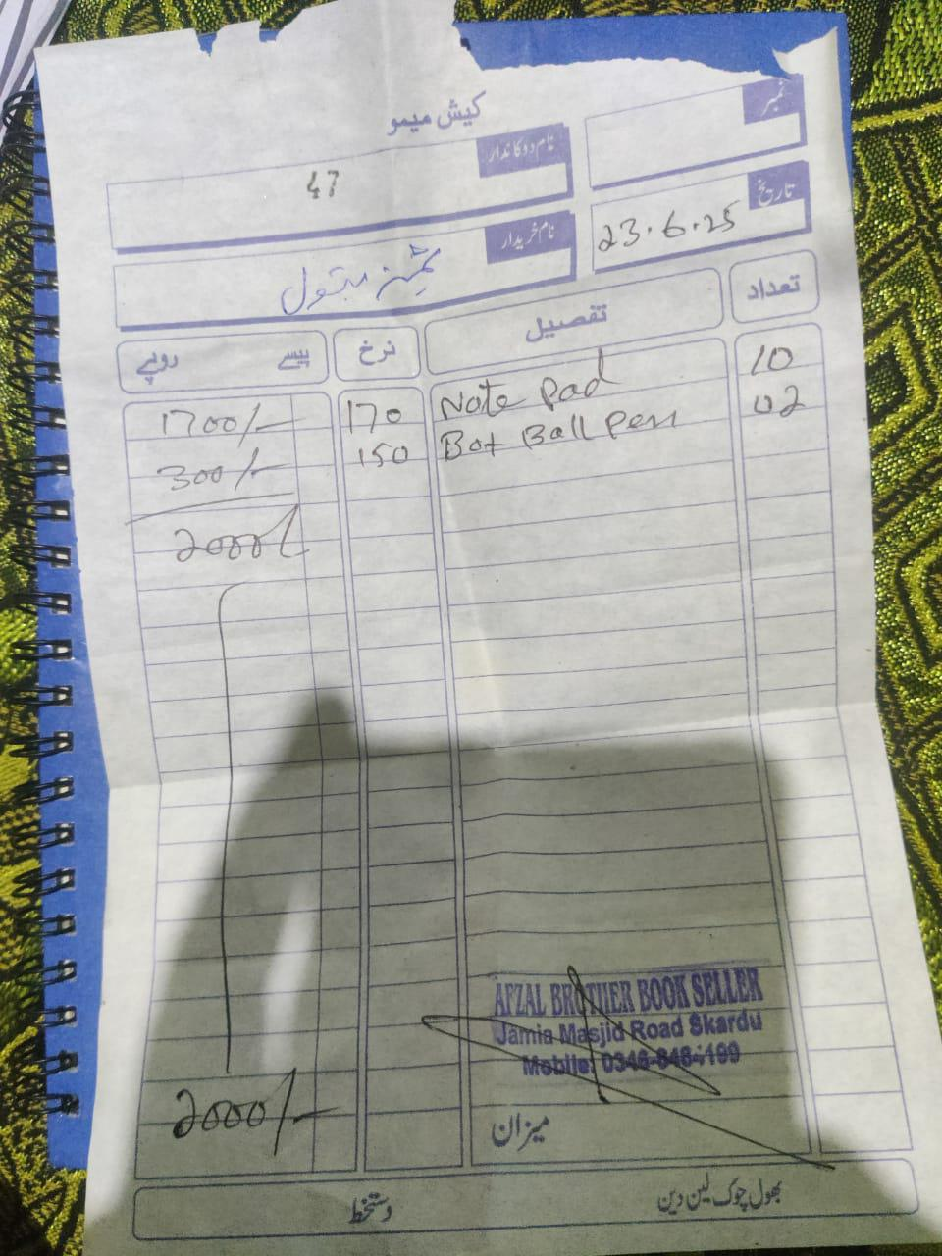
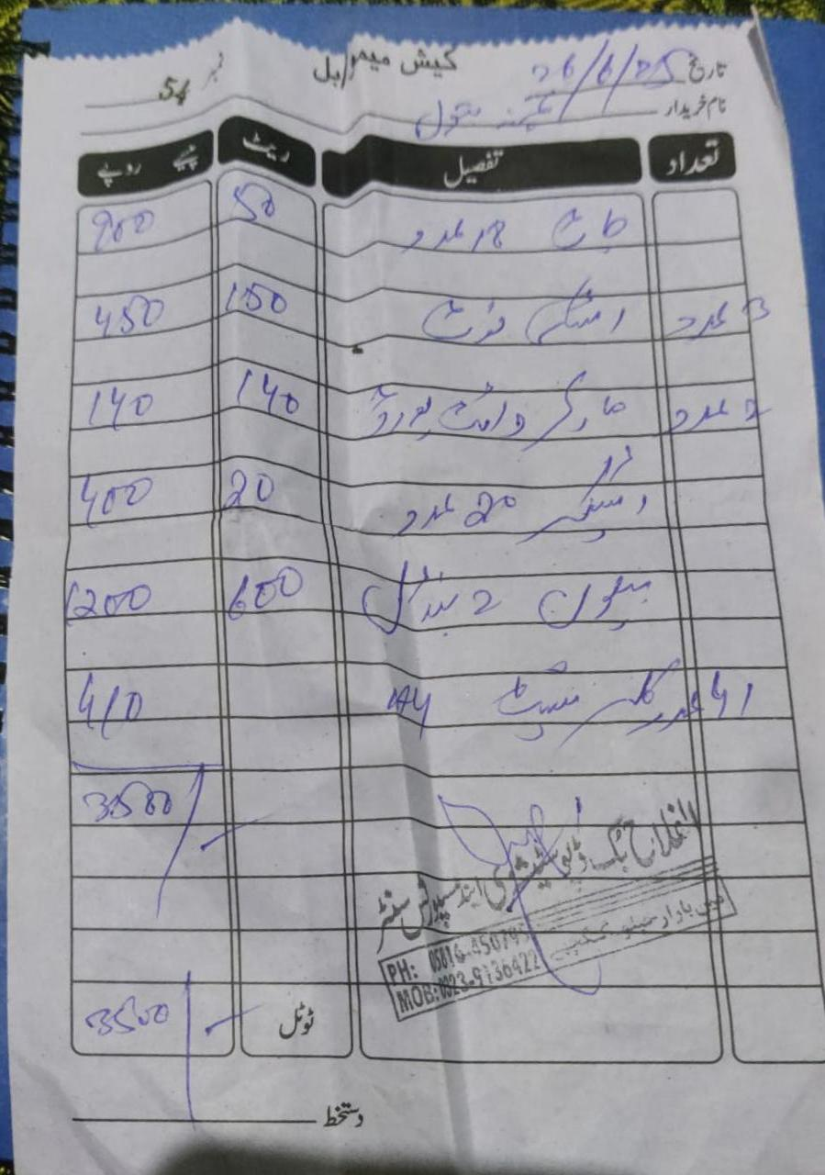
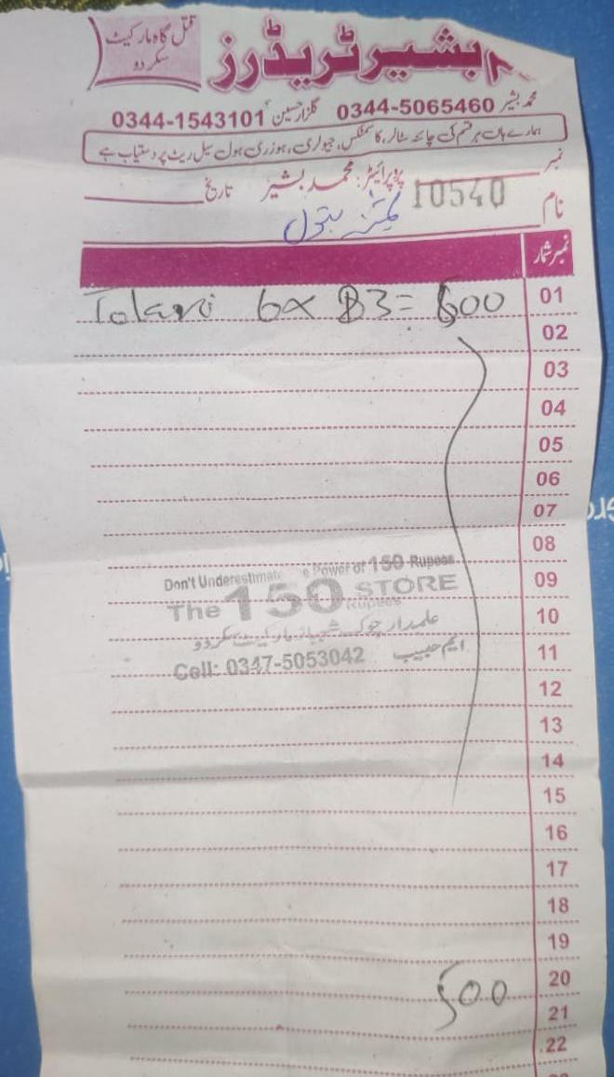
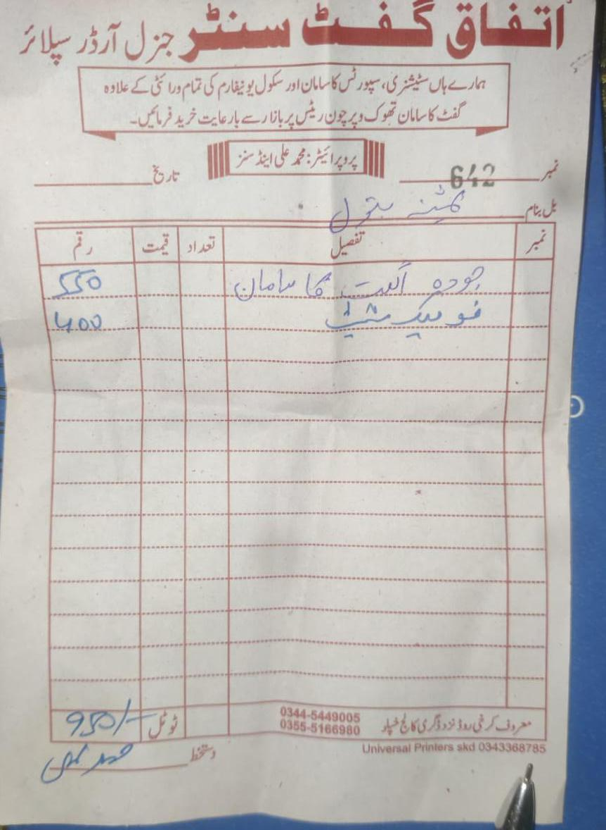

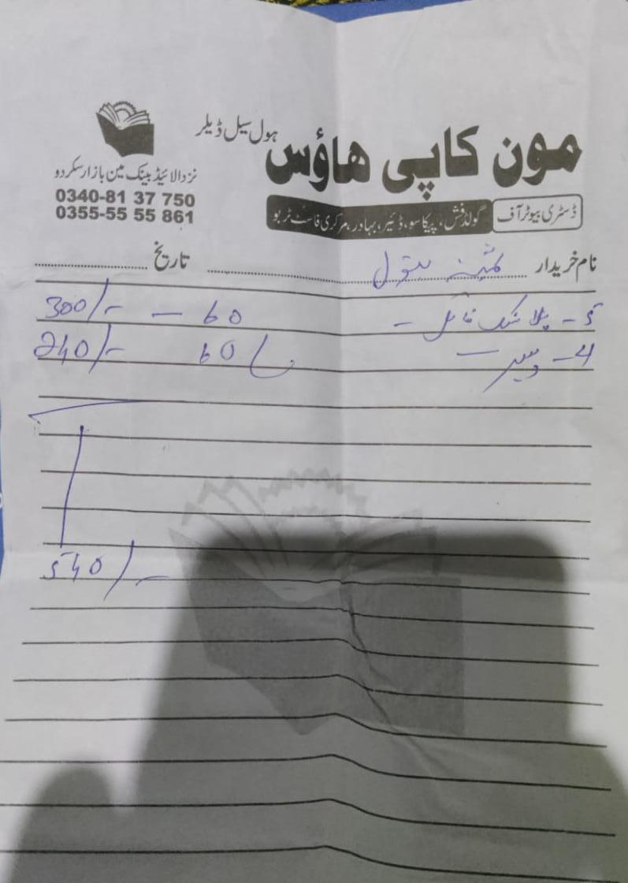
.

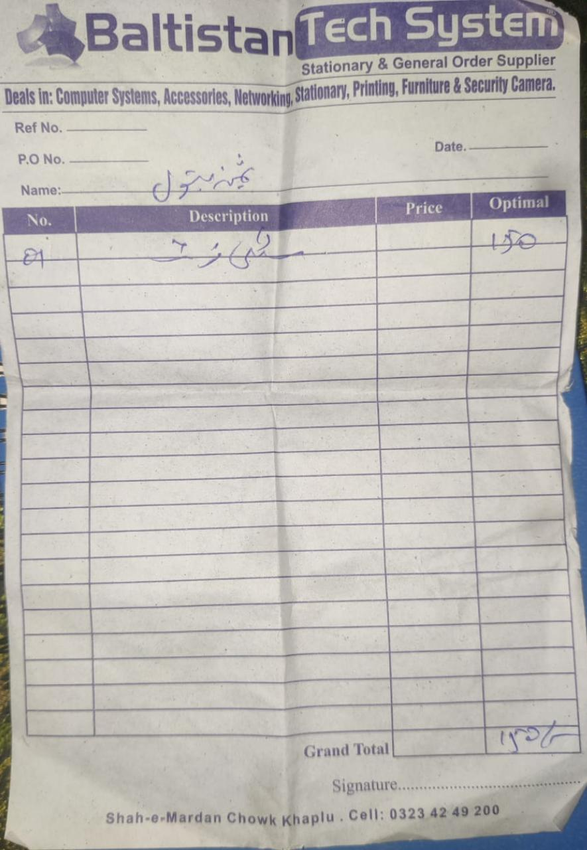

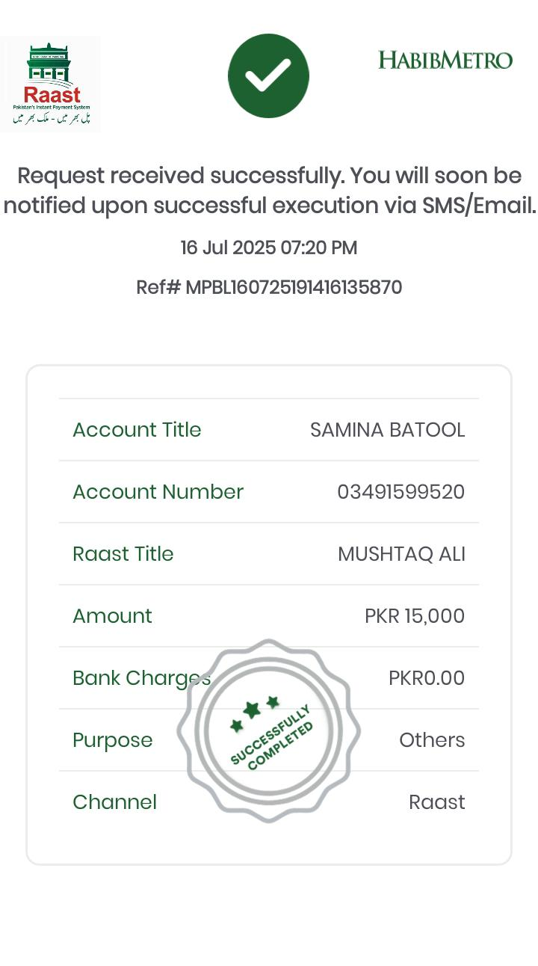
Travel LT capacity Building training and life skills workshop

